**ANALYSIS SWIGGY: BANGALORE DELIVERY OUTLET DATA**

**Wireframe Documentation**

iNeuron.ai

Presented By: **Mohammad Wasiq**

GitHub: [https://github.com/MohammadWasiq0786/Swiggy-Delivery-Analysis](https://github.com/MohammadWasiq0786/Swiggy-Delivery-Analysis%20Detection)

LinkedIn: <https://www.linkedin.com/in/mohammadwasiq0/>

Analysis Swiggy: Bangalore Delivery Outlet Wireframe Documentation

# Dashboard 1

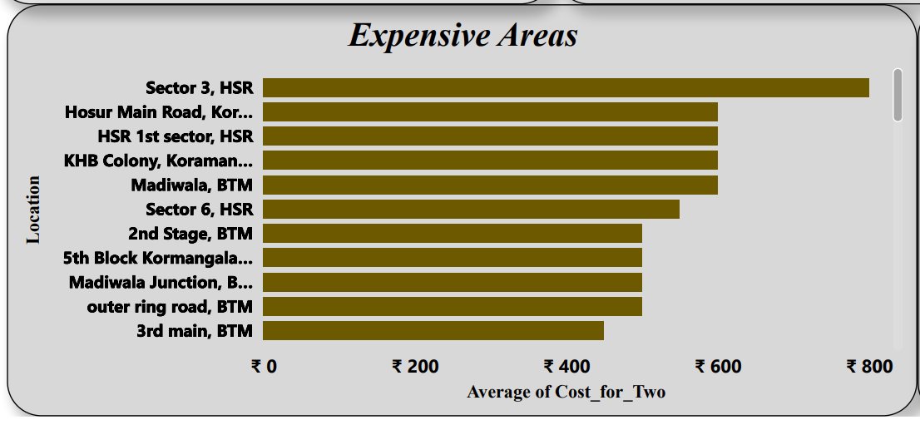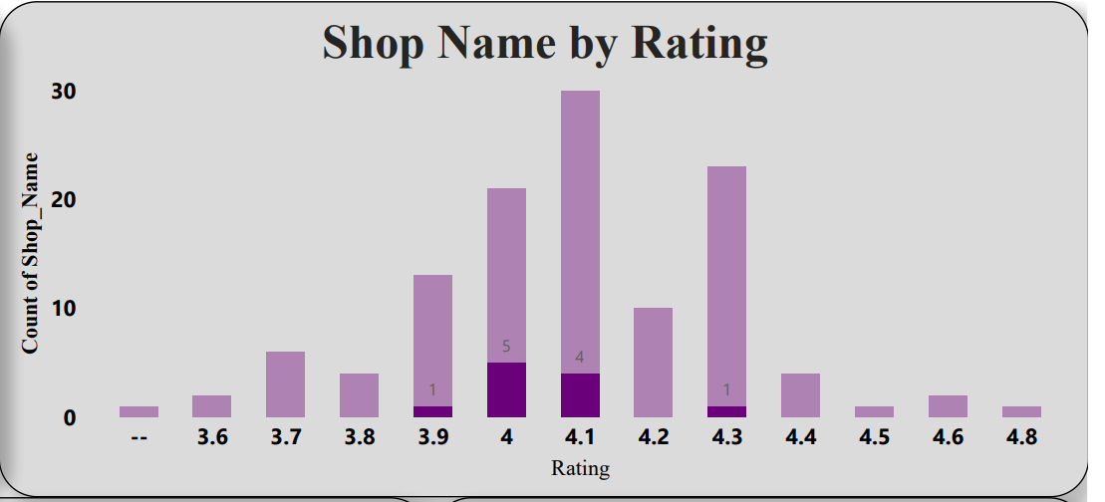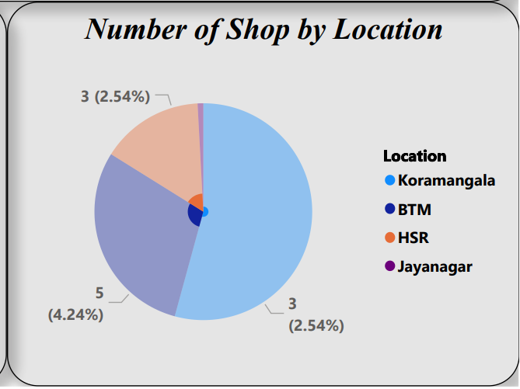

1. 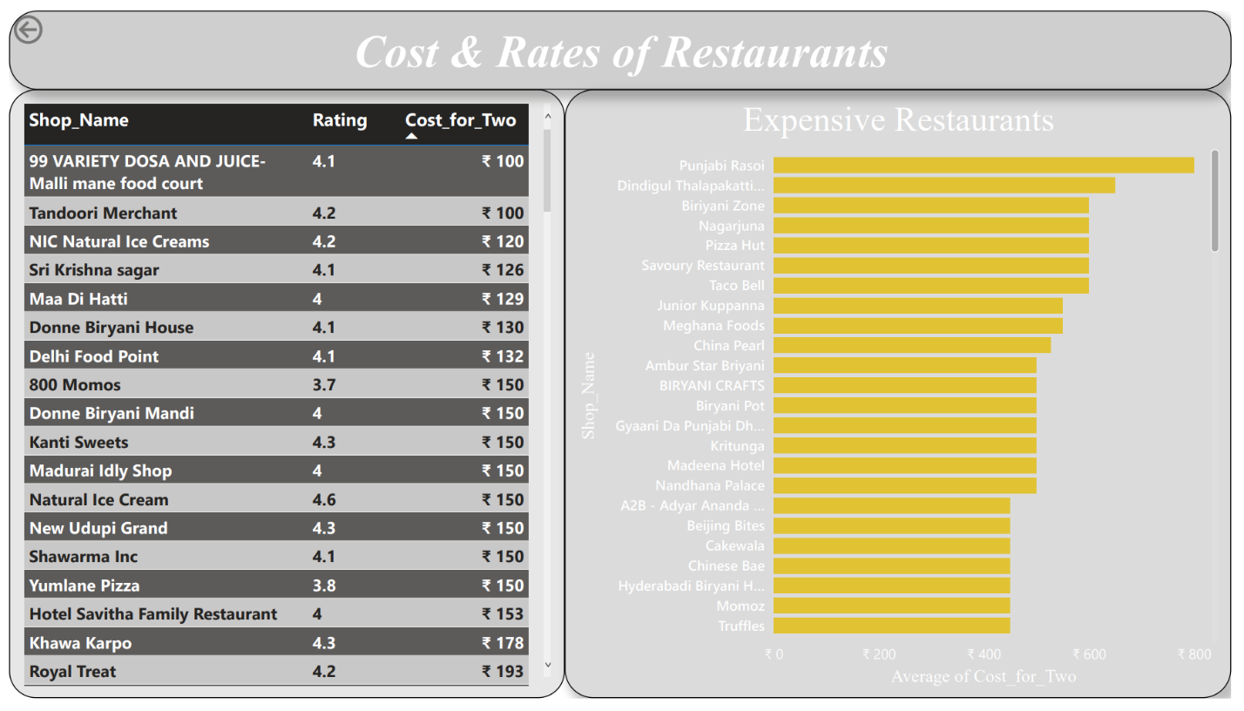**Dashboard 2**

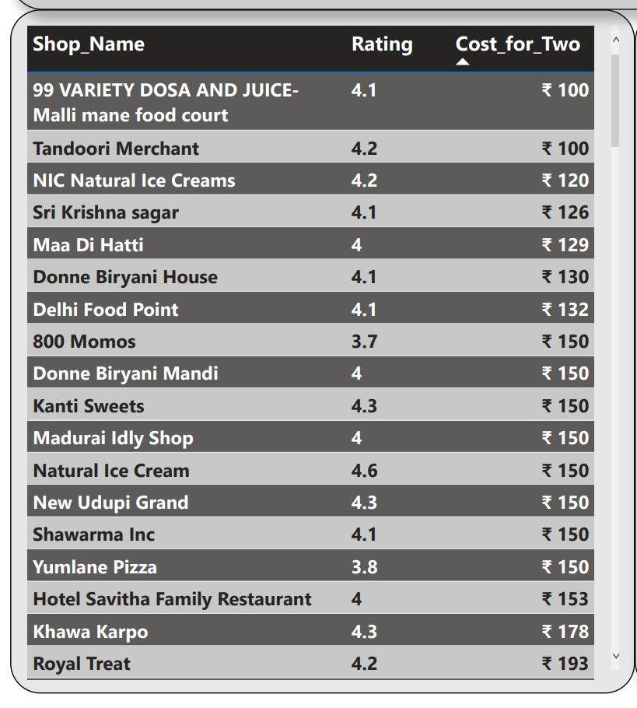

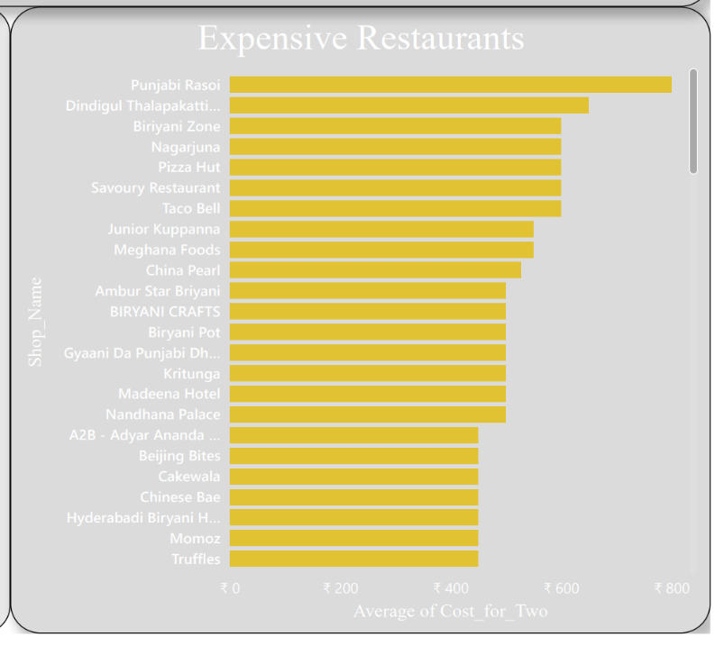

1. 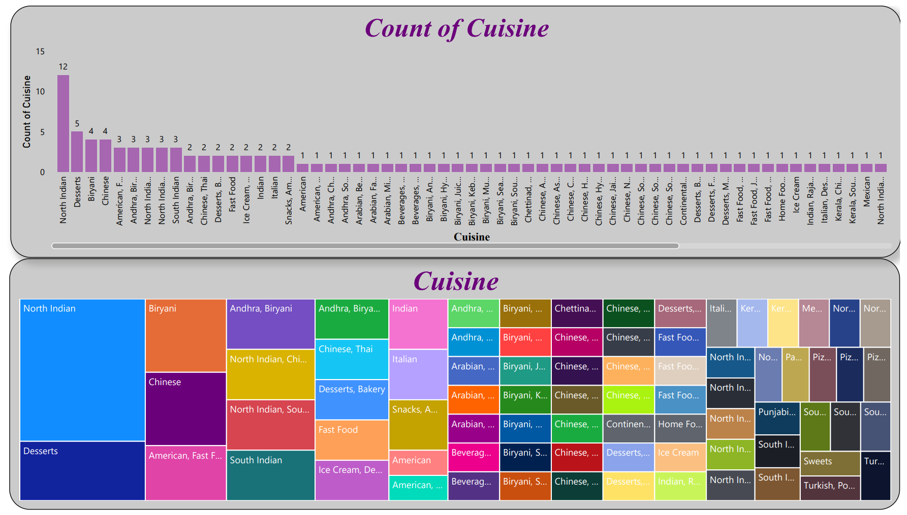**Dashboard 3**

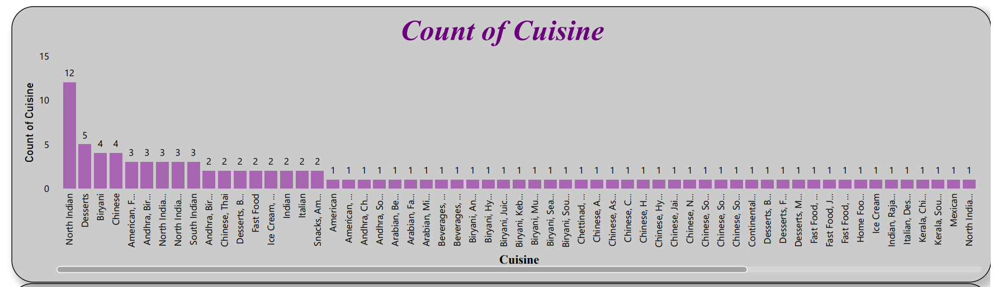

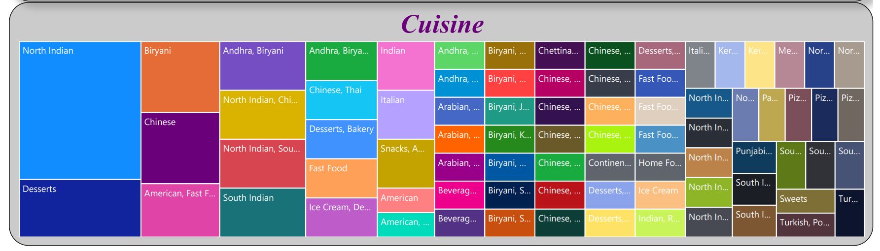

1. **Dashboard 4**

